**AIM**

**CODE:**

**Step 1:**

Create a folder named Data in the C Drive.

Create rs1,rs2,rs3 as sub directories to Data folder.

Open a cmd in the bin folder of the mongo.

**Query 1:**

>mongo --port 27018

>start mongod -replSet qwerty -logpath \Data\rs1\1.log -dbpath \Data\rs1 --port 27018

>start mongod -replSet qwerty -logpath \Data\rs2\2.log -dbpath \Data\rs2 --port 27019

>start mongod -replSet qwerty -logpath \Data\rs3\3.log -dbpath \Data\rs3 --port 27020

**Step 2:**

Open a mongoshell.

**Query 2:**

>config={_id:"qwerty",members:[{_id:0,host:"localhost:27018"},{_id:1,host:"localhost:27019"},{_id:2,host:"localhost:27020"}]}

> rs.initiate(config)

> show dbs

**Step 3:**

Open another mongosh

**Query 3**

> mongo --port 27019

> rs.secondaryOk()

>show dbs

**OUTPUT:**

**Query 1:**

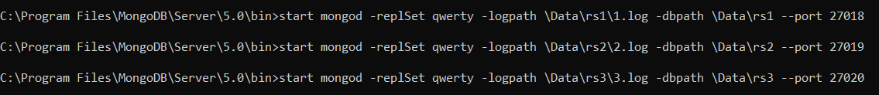

**Query 2:**

**Query 3:**



**RESULT:**